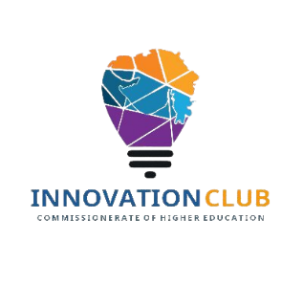
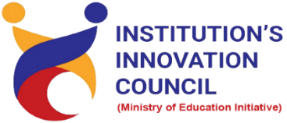

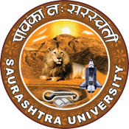
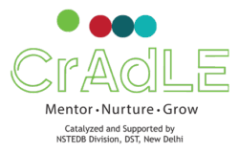

Mirchi Start-up Express
13 April 2022
At
Department of Business Management
Saurashtra University Campus, Rajkot
Contents
Saurashtra University – IIC 2
Event Schedule 2
Event Registration Link 2
Brief about Event 3
Key Points 3
Outcome 3
About the Speaker/Chief Guest 4
5
Connect Us: 6

Saurashtra University – IIC
The university is dedicated to instruction, research, and extending knowledge to the public (public service). Ministry of Education (MoE), Govt. of India has established ‘MoE’s Innovation Cell (MIC)’ to systematically foster the culture of Innovation among all Higher Education Institutions (HEIs). The primary mandate of MIC is to encourage, inspire and nurture young students by supporting them to work with new ideas and transform them into prototypes while they are informative years. Saurashtra University is one the Organization that have constituted the IIC to foster the vision of MoE and be a part for the promotion and development of innovation ecosystem.

Event Schedule

Event Registration Link

bit.ly/SU-EDII-MBC

Brief about Event
@susecrajkot in partnership with @ediiahmedabad and @cradleedii is organizing Regional Bootcamp at The Saurashtra University, Rajkot to promote start-up culture, entrepreneurship, government funding schemes, and start-up internship fair and Mirchi Start-up Express 2022
This is an exclusive event for start-up, students and new age entrepreneurs from the Gujarat start-up ecosystem to arrive at one place, dish out their entrepreneurial endeavours and experiences, discuss the opportunities to receive funds from government schemes, get and offer start-up internships, learn about entrepreneurship through post-graduate programs, and view in person the state of art incubation facilities.

Key Points

During the session, below mentioned points were discussed:
- Importance of start-up culture, entrepreneurship, government funding schemes.
- Needs for start-ups.
- Validity of various government funding schemes.
- Examples of various types of government funding schemes.
- How to apply for government funding schemes.
- FAQs related to start-up culture, entrepreneurship, government funding schemes.

Outcome

As per the event, various types of government funding schemes were understood by the speakers with examples of start-up culture, entrepreneurship, government funding schemes etc.
Also, as it was related to entrepreneur and awareness creation, a basic knowledge of start-ups, how it works, how it can be registered, with various examples etc.

About the Speaker/Chief Guest

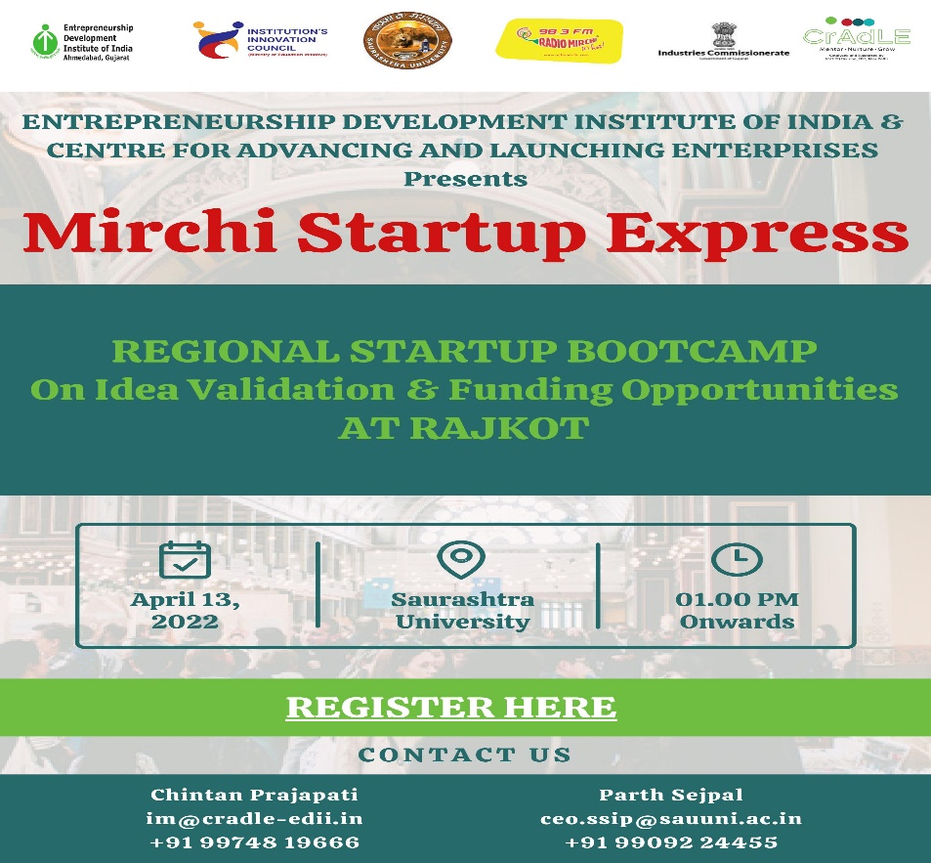

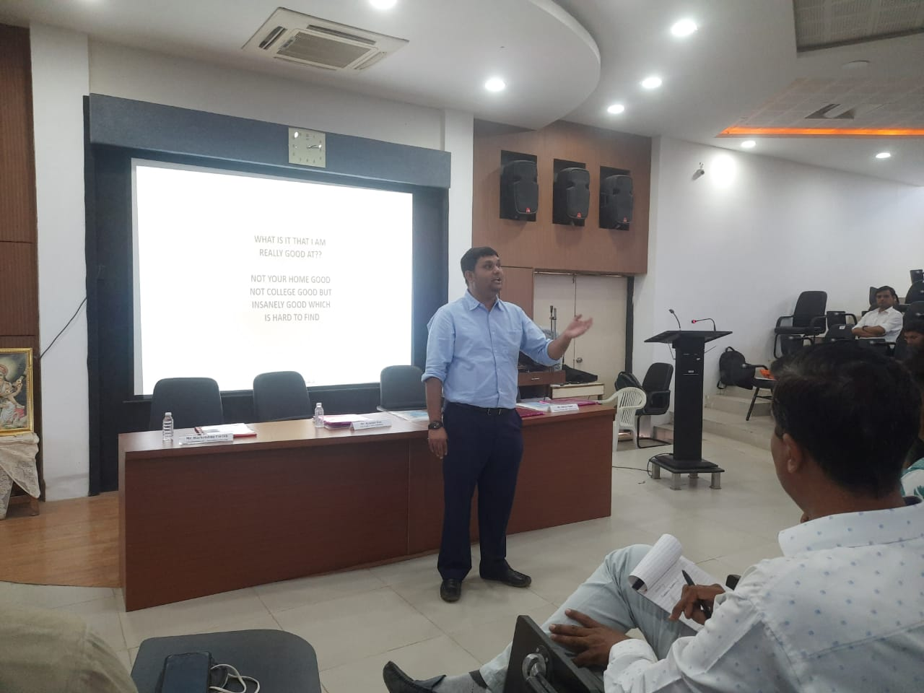

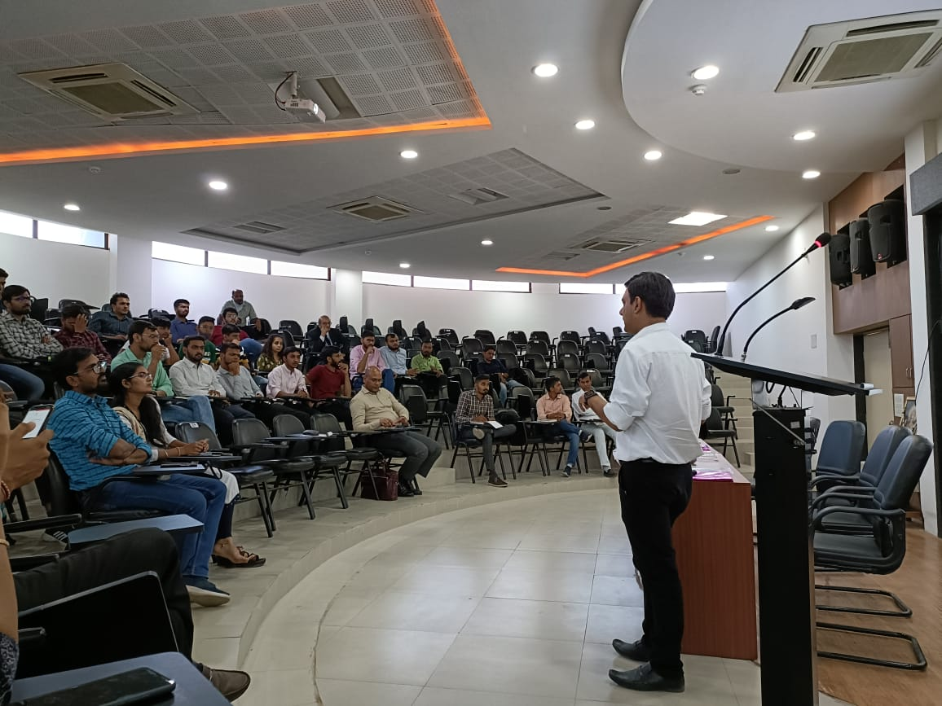

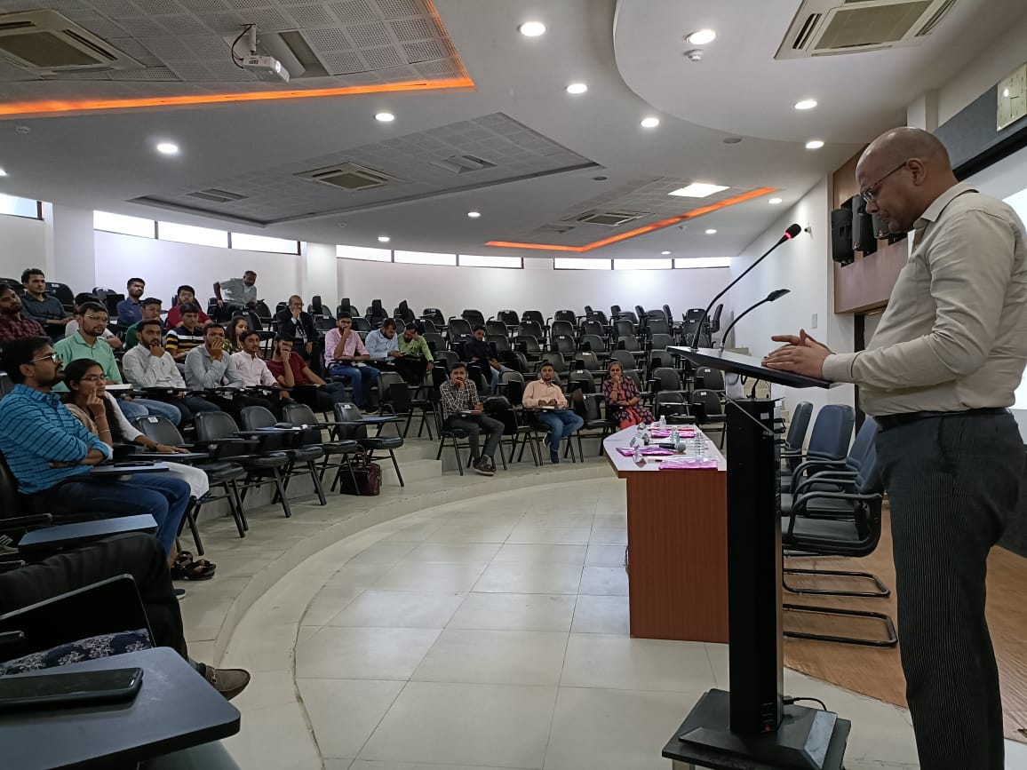

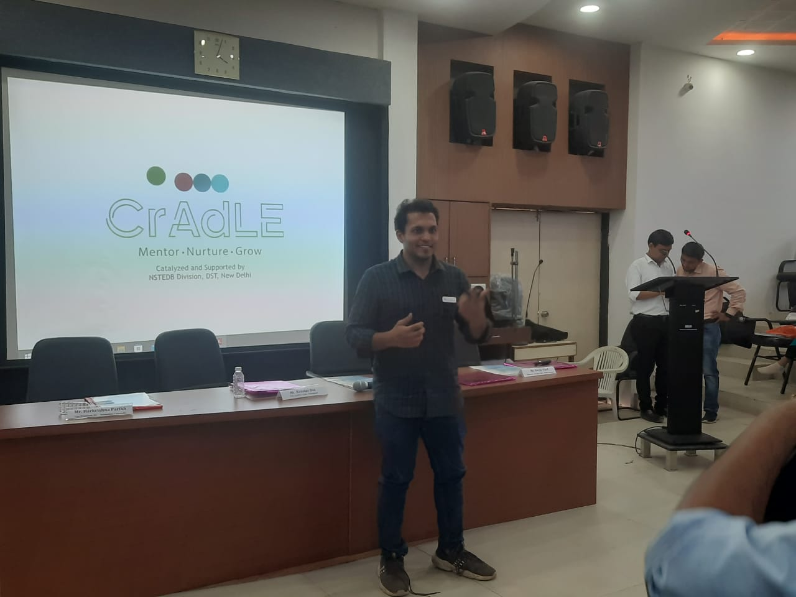

Connect Us:
https://www.linkedin.com/company/susec iic@sauuni.ac.in
https://www.facebook.com/iicsauuni bit.ly/SU-SSIP Location
https://www.instagram.com/susecrajkot

